Abstract

Nowadays entrance exams have become very important in various places for recruiting individuals for occupation, higher studies, etc. A lot of people would attend an entrance exam which makes the various processes involved in an entrance exam very difficult for mere human hands to handle and it would also become time consuming. So we are developing a program ‘Entrance Operator’ which helps to fasten the various processes such as application, approval, result publication using C++ programming language and some of its special features such as classes, their objects and operations on binary data files.

# **ENTRANCE**

# **OPERATOR**

ACKNOWLEDGEMENT

First and foremost I would thank God almighty for his blessing to keep me energetic throughout the making of this project.

I wish to extend my gratitude to Ms. Deepa Das, our principal and Mr. Vinod, our vice principal for providing us with the opportunity and platform to perform the requisite experiments behind the completion of this project.

I sincerely acknowledge the guidance and support offered by our teacher Ms. Neethu, without which this endeavor would not have been possible.

Last but not the least I thank my friends who helped to collect all the necessary information and materials for this project.

INDEX

|  |  |  |
| --- | --- | --- |
| S.No. |  | Page no. |
| 1. | Introduction |  |
| 2. | System Design |  |
| a)Module Description |  |
| b)Data Flow Diagram |  |
| 3. | Basic Concepts |  |
| 4. | Hardware & Software requirements |  |
| 5. | Source Code |  |
| 6. | Result |  |
| 7. | Conclusion & Future enhancements |  |
| 8. | Reference |  |

1. Introduction

This project is based on the development of a program

‘Entrance Operator’ which is used to simplify and fasten up the various processes involved in an entrance exam held in a particular centre. The program is encrypted using C++ programming language which is an Object Oriented Programming language. Here features of C++ such as classes, objects, binary files are used. At first the details of the entrance exam such as syllabus, minimum qualifications and date of examination are to be given. After that the program will show a menu including options such as guide, application, approval, confidential and menu. Guide helps the user to clarify doubts based on the program and the entrance exam. Application involves entering details of the applicants. Approval involves verification of the necessary certificates by the officer and the approved candidate will be given a register number by the program. Then after the exam the officer is to enter the marks of each candidate through the option confidential. After that the result will be published in the option result where the whole rank list and the individual result can be viewed.

2. System Design

a) Module Description

Module 1: At first the details of the entrance exam such as the name of the entrance exam, date of the examination, syllabus and minimum qualifications of the applicant are to be entered.

Module 2: If the user has any doubts regarding the program or that regarding the entrance exam he/she can clarify it in Guide.

Module 3: The details of each applicant such as name, address, school/college attended/attending, marks in 12th board exam are to be entered .The applicant is then requested to present necessary certificates to the officer so that he/she may be approved and would be given a register number.

Module 4: The mark of each candidate is to be entered to program by the officer which involves a security procedure.

Module 5: The program will then publish the rank list and it can also be used to view individual result of each candidate.

b) Data Flow Diagram

Level 0

Main Menu 1.Guide 2.Appliction 3.Approval 4.Confidential 5.Result

Start

Enter details of new entrance exam

Level 1

1. How to use operator 2.Syllabus 3.Qualification 4.Other information

Go to Start

Level 2

Approval

Enter details of the applicant

Level 3

Enter Password

If

***Incorrect***

***Correct***

Enter Marks

Result

Individual Result

3. Basic Concepts

**C++** is a general-purpose programming language. It has imperative and object-oriented programming features, while also providing the facilities for low-level memory manipulation. C++ has also been found useful in many other contexts, including desktop applications, servers, performance-critical applications and entertainment software. C++ is an object-oriented programming (OOP). It offers classes, which provide the four features commonly present in OOP languages: abstraction, encapsulation, inheritance, and polymorphism. One distinguishing feature of C++ classes compared to classes in other programming languages is support for deterministic destructors, which in turn provide support for the Resource Acquisition is Initialization (RAII) concept. Abstraction means hiding the background details and showing the necessary details to the user. Modularity is another feature of C++ means decomposition of large programs to smaller functions where each function will have a particular role to perform. Inheritance allows one data type to acquire properties of other data types. Encapsulation is the hiding of information to ensure that data structures and operators are used as intended and to make the usage model more obvious to the developer. C++ provides the ability to define classes and functions as its primary encapsulation mechanisms. Within a class, members can be declared as either public, protected, or private to explicitly enforce encapsulation. Polymorphism enables one common interface for many implementations, and for objects to act differently under different circumstances.

Some of the header files used in this program are fstream.h, conio.h, graphics.h, stdio.h, process.h, dos.h.fstream.h has been used for file handling, graphics.h for some graphical implementations, conio.h for better output by using functions such as clrscr(), getch(),etc, process.h for the function exit(0) which is used to terminate the program at required intervals, stdio.h for getting and showing character strings and dos.h for the function delay() which helps in pausing the compiler for a required time and also for showing the current date.

4. Hardware and Software

Requirements

Hardware specifications:

* Processor : Intel Pentium Dual Core E54000
* Operating System : Windows 7 64-bit
* 512 MB RAM
* 30 MB free hard disk space

Software used:

* Front end : Turbo C++
* Back end : Data file

5. Source Code

#include<fstream.h>

#include<conio.h>

#include<stdio.h>

#include<string.h>

#include<graphics.h>

#include<dos.h>

#include<process.h>

class ENTR //class for ENTN,date

{

char ENTN[40],ins[1000];

int date[3];

public:

char cho;

void fnt()

{

int n=0;

char e[8];

strcpy(e,"E");

int gd=DETECT,gm;

initgraph(&gd,&gm,"c:\\turboc3\\bgi");

setbkcolor(1);

setcolor(14);

settextstyle(5,0,4);

struct date d;

getdate(&d);

printf("%d ", d.da_day);

printf("%d ", d.da_mon);

printf("%d ", d.da_year);

for(int l=0,x=20,y=80,z=100;l<385;l++,x++)

{

arc(x,y,0,90,60);

delay(5);

if(l==z)

{

setcolor(2);

outtextxy(l,30,e);

setcolor(14);

z+=40;

if(l==100){strcpy(e,"N");}

if(l==140){strcpy(e,"T");}

if(l==180){strcpy(e,"R");}

if(l==220){strcpy(e,"A");}

if(l==260){strcpy(e,"N");}

if(l==300){strcpy(e,"C");}

if(l==340){strcpy(e,"E");}

}

}

strcpy(e,"O");

for(int l1=100,x1=120,y1=160,z1=200;l1<485;l1++,x1++)

{

arc(x1,y1,0,90,60);

delay(5);

if(l1==z1)

{

setcolor(2);

outtextxy(l1,105,e);

setcolor(14);

z1+=40;

if(l1==200){strcpy(e,"P");}

if(l1==240){strcpy(e,"E");}

if(l1==280){strcpy(e,"R");}

if(l1==320){strcpy(e,"A");}

if(l1==360){strcpy(e,"T");}

if(l1==400){strcpy(e,"O");}

if(l1==440){strcpy(e,"R");}

}

}

cout<<"\n\n\n\n\n\n\n\n\n\n\n\tOperate new\ entrance exam(y)Continue with previous one(n) :";

cin>>cho;

if(cho=='y')

{

closegraph();

fstream cl;

cl.open("ANDF",ios::out);

cl.close();

cout<<"Instructions for operating new entrance exam\n";

ifstream p;

p.open("Ins");

p.seekg(0);

while(n<5)

{

p.read((char*)&ins,sizeof(ins));

puts(ins);

n++;

}

cout<<"\n\tEnter name of entrance exam:";

gets(ENTN);

ofstream p4;

p4.open("ENTN");

p4.write((char*)&ENTN,sizeof(ENTN));

cout<<"\n\tEnter date of examination(dd mm yyyy):";

ofstream p5;

p5.open("DATE");

for(int t=0;t<3;t++)

{

cin>>date[t];

p5<<date[t]<<"\t";

}

cout<<"\n\tEnter minimum qualifications of applicant of exam\n";

ofstream p1;

p1.open("Ins1");

gets(ins);

p1.write((char*)&ins,sizeof(ins));

cout<<"\n\tEnter Syllabus\n";

gets(ins);

ofstream p2;

p2.open("Ins2");

p2.write((char*)&ins,sizeof(ins));

cout<<"\n\tEnter other details/Enter Nill\n";

gets(ins);

ofstream p3;

p3.open("Ins3");

p3.write((char*)&ins,sizeof(ins));

cout<<"\n\tPress Enter";

getch();

}

else if(cho=='n')

{

cout<<"\n\tWelcome to ";

ifstream p4;

p4.open("ENTN");

p4.read((char*)&ENTN,sizeof(ENTN));

puts(ENTN);

cout<<"\tDate of examination(dd mm yyyy):";

ifstream p5;

p5.open("DATE");

for(int t1=0;t1<3;t1++)

{

p5>>date[t1];

cout<<date[t1]<<" ";

}

cout<<"\n\tPress Enter";

getch();

}

closegraph();

}

char rtcho()

{return cho;}

}entrance;

class CNDT //Class for candidate

{

char n[60],cst[20],sch[100],addr[100],ecn[4];

float m,admt,tm;

double brdrl;

public:

void appfom()

{

float phy,mat,eng,chem;

cout<<"\n\n\n\nEnter the following details\n\n1.Name :";

gets(n);

cout<<"\n2.School/College :";

gets(sch);

cout<<"\n3.Cast (General/OBC/SC/ST) :";

gets(cst);

cout<<"\n4.Address(House no./Nagar/Post Office/City/State)\n ";

gets(addr);

cout<<"\n5.Enter roll number of 12th board exam along with the year of exam\n(Eg.If 1214 is the roll number and exam was on 2007 then write 12142007)\n";

cin>>brdrl;

cout<<"\n6.Enter economic status(APL/BPL):";

gets(ecn);

cout<<"\n7.Enter marks of the following subject in your +2 board exam in percent\n";

cout<<"\n\t\tMathematics :";

cin>>mat;

cout<<"\t\tPhysics :";

cin>>phy;

cout<<"\t\tChemistry :";

cin>>chem;

cout<<"\t\tEnglish :";

cin>>eng;

m=(mat/100)*40+(phy/100)*25+(chem/100)*15+(eng/100)*10;

admt=0.0;

tm=0.0;

}

void show()

{

cout<<"\n1.Name :";

puts(n);

cout<<"\n2.School/College :";

puts(sch);

cout<<"\n3.Cast (General/OBC/SC/ST) :";

puts(cst);

cout<<"\n4.Economic status(APL/BPL):";

puts(ecn);

cout<<"\n5.Address(House no./Nagar/Post Office/City/State)\n ";

puts(addr);

}

float rtnadmt()

{return admt;}

double rtnbrl()

{return brdrl;}

void rtnadmt(float a)

{admt=a;}

float rtnmrk()

{return m;}

void asstm(float a)

{tm=a;}

float rtntm()

{return tm;}

void shown()

{puts(n);};

void assttm()

{

if(!strcmp(cst,"OBC"))

tm+=1;

if(!strcmp(cst,"SC")||!strcmp(cst,"ST"))

tm+=2;

if(!strcmp(ecn,"BPL"))

tm+=3;

}

}o[20],obj[20],bj[20],rk[20],frk[20],ob;

void main() //Main function

{

entrance.fnt();

int cho,check=0;

char c,inst[1000];

beg:

clrscr();

cout<<"\n\n\n\n\n\t\t1.Guide\n\t\t2.Apply for entrance exam\n\t\t3.Check for approval\n\t\t4.Check result\n\t\t5.Confidential\n\t\t6.Exit\n\n\t\tEnter your option :";

cin>>cho;

delay(100);

clrscr();

switch(cho)

{

case 1:gd: //Guide

clrscr();

cout<<"\n\n\n\n\t\t1.How to use ENTRANCE OPERATOR\n\t\t2.Minimum qualification of applicant\n\t\t3.Syllabus\n\t\t4.Other instructions\n\t\t5.Go back to main menu\n\n\t\tEnter your option :";

cin>>c;

switch(c)

{

case '1':clrscr();

int n=0;

ifstream pn;

pn.open("Ins");

pn.seekg(0);

while(n<5)

{

pn.read((char*)&inst,sizeof(inst));

puts(inst);

n++;

}

break;

case '2':clrscr();

ifstream pn1;

pn1.open("Ins1");

pn1.read((char*)&inst,sizeof(inst));

puts(inst);

break;

case '3':clrscr();

ifstream pn2;

pn2.open("Ins2");

pn2.read((char*)&inst,sizeof(inst));

puts(inst);

break;

case '4':clrscr();

ifstream pn3;

pn3.open("Ins3");

pn3.read((char*)&inst,sizeof(inst));

puts(inst);

break;

case '5':goto beg;

default:cout<<"Wrong option";

goto gd;

}

cout<<"Press Enter to go back";

getch();

goto gd;

case 2:ofstream putd; //Application(Complete)

putd.open("ANDF",ios::app|ios::binary);

int in=0;

appl:

o[in].appfom();

cout<<"Application form has been completed.\n\nPress 'R' if you want to redo\nPress 'G' to go to main menu\nPress any other key to exit\n";

cin>>c;

if(c=='G')

{

putd.write((char*)&o[in],sizeof(o[in]));

in++;

putd.close();

goto beg;

}

else if(c=='R')

{

clrscr();

goto appl;

}

else

{

putd.write((char*)&o[in],sizeof(o[in]));

putd.close();

cout<<"Closing...";

delay(1000);

exit(0);

}

break;

case 3:double brol,admtn; //Approval

char vrf;

int incr=0;

cout<<"Enter board roll number with year of applicant to be verified:";

cin>>brol;

ifstream src;

src.open("ANDF",ios::binary);

while(src)

{

src.read((char*)&obj[incr],sizeof(obj[incr]));

if(obj[incr].rtnbrl()==brol)

{

obj[incr].show();

cout<<"Press 'v' to approve this applicant for the exam ,'r' to reject:";

cin>>vrf;

ofstream app;

fstream admt;

admt.open("ADMT",ios::binary|ios::in|ios::out);

if(entrance.rtcho()=='y'&&check==0)

{

app.open("APP",ios::binary|ios::out);

check=1;

}

else

app.open("APP",ios::binary|ios::app);

if(vrf=='v')

{

admt>>admtn;

admtn++;

obj[incr].rtnadmt(admtn);

admt.seekp(0);

admt<<admtn;

cout<<"The admit roll number of candidate is:"<<admtn;

app.write((char*)&obj[incr],sizeof(obj[incr]));

}

admt.close();

app.close();

incr++;

break;

}

}

src.close();

cout<<"\nPress 'G' to go back to main window or press any other key to exit :";

cin>>c;

if(c=='G')

goto beg;

else

exit(0);

break;

case 4:float ttlm[20];

int ad=0,ls=0,optn;

ifstream r; //Result

ofstream rnk;

r.open("Store");

rnk.open("RnkLst",ios::out);

while(r)

{

r.read((char*)&rk[ad],sizeof(rk[ad]));

ad++;

}

r.close();

for(int k=0;k<ad;k++)

for(int h=0;h<ad;h++)

if(rk[h].rtntm()<rk[h+1].rtntm())

{

ob=rk[h];

rk[h]=rk[h+1];

rk[h+1]=ob;

}

while(ls<ad)

{

rnk.write((char*)&rk[ls],sizeof(rk[ls]));

ls++;

}

rnk.close();

rslt:

clrscr();

cout<<"\n\n\t\t\tRESULT\n\t1.Show full result\n\t2.Search for individual result\n\n\tEnter your option:";

cin>>optn;

clrscr();

if(optn==1)

for(int sh=0;sh<ad-1;sh++)

{

cout<<sh+1<<".";

rk[sh].shown();

}

if(optn==2)

{

double broln;

cout<<"Enter your board roll number with year:";

cin>>broln;

ifstream showr;

showr.open("RnkLst");

ls=0;

while(ls<ad)

{

showr.read((char*)&ob,sizeof(ob));

ls++;

if(ob.rtnbrl()==broln)

{

cout<<"Your name is ";

ob.shown();

cout<<"Your rank is:"<<ls;

}

}

}

cout<<"\nPress 'G' to go back to main window\nPress'R'to check result again\nPress any other key to exit\n";

cin>>c;

if(c=='G')

goto beg;

if(c=='R')

goto rslt;

else

exit(0);

break;

case 5:char psw[20]; //Entering marks(Complete)

int inr=0;

float mark,mark1,tmrk;

passw:

clrscr();

cout<<"\n\n\n\n\n\t\t\tEnter password:";

gets(psw);

if(!strcmp(psw,"Bjarne*Stroustrup"))

{

cout<<"\t\t\t\tPress Enter";

getch();

clrscr();

cout<<"Enter marks of candidates against admit numbers given below\n";

fstream mrk;

fstream str;

mrk.open("APP",ios::binary|ios::in);

str.open("Store",ios::binary|ios::out);

while(mrk)

{

mrk.read((char*)&bj[inr],sizeof(bj[inr]));

if(bj[inr].rtnadmt()!=0)

{

cout<<inr+1<<"."<<bj[inr].rtnadmt()<<":";

cin>>mark;

mark1=bj[inr].rtnmrk();

tmrk=mark+mark1;

bj[inr].asstm(tmrk);

bj[inr].assttm();

str.write((char*)&bj[inr],sizeof(bj[inr]));

}

inr++;

}

mrk.close();

str.close();

}

else

{

cout<<"\n\n\t\t\tSorry wrong password";

cout<<"\nPress 'R' to reenter password\nPress 'G' to go back to main window or press any other key to exit :";

if(c=='R')

goto passw;

if(c=='G')

goto beg;

else

exit(0);

}

cout<<"\nPress 'G' to go back to main window or press any other key to exit :";

cin>>c;

if(c=='R')

goto passw;

if(c=='G')

goto beg;

else

exit(0);

break;

case 6:clrscr();

cout<<"\n\n\n\n\n\t\t\t\tClosing...";

delay(1000);

exit(0);

default:cout<<"\n\n\n\n\n\t\t\t\tWrong option";

delay(1000);

goto beg;

}

}

6.Result

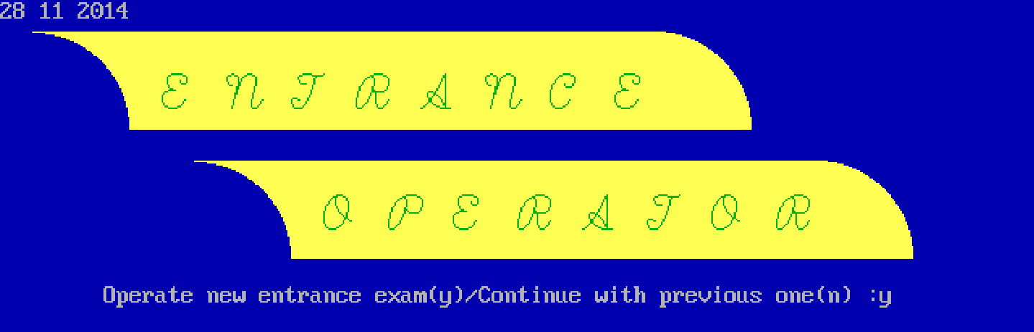

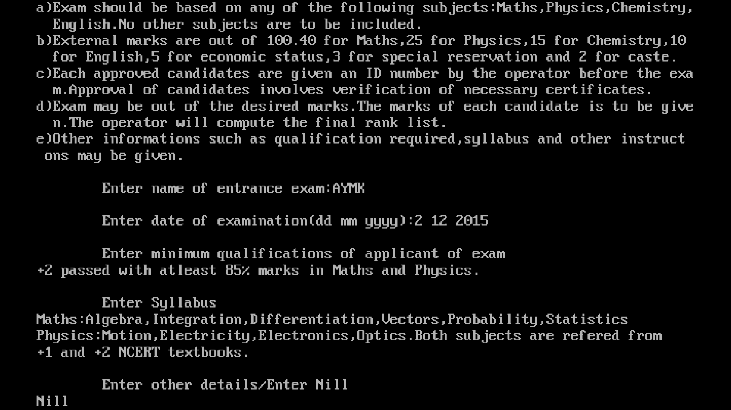

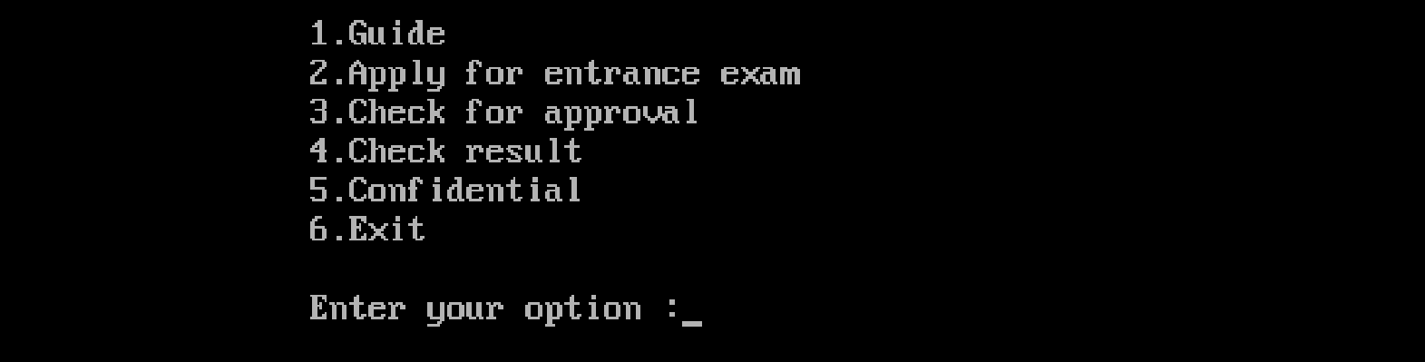



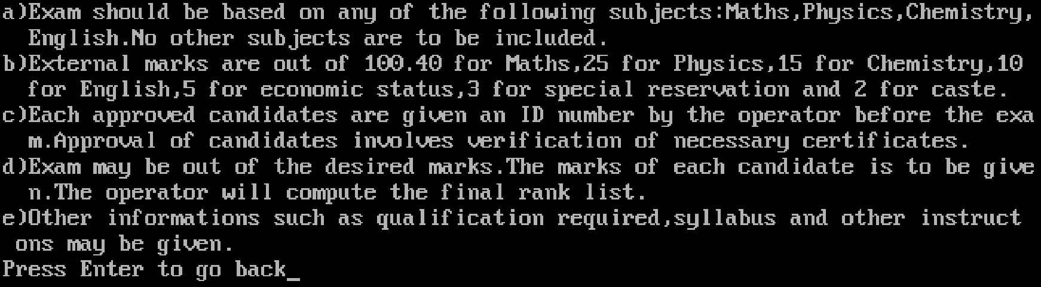



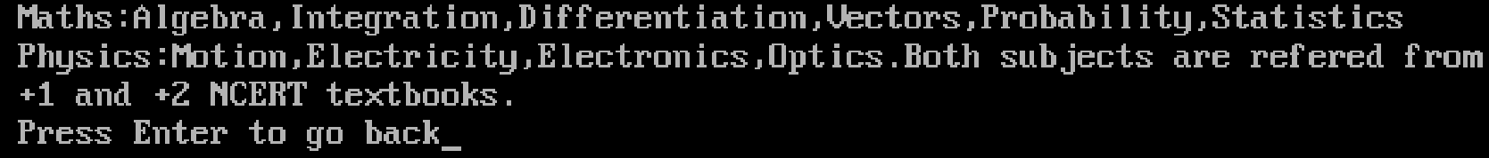

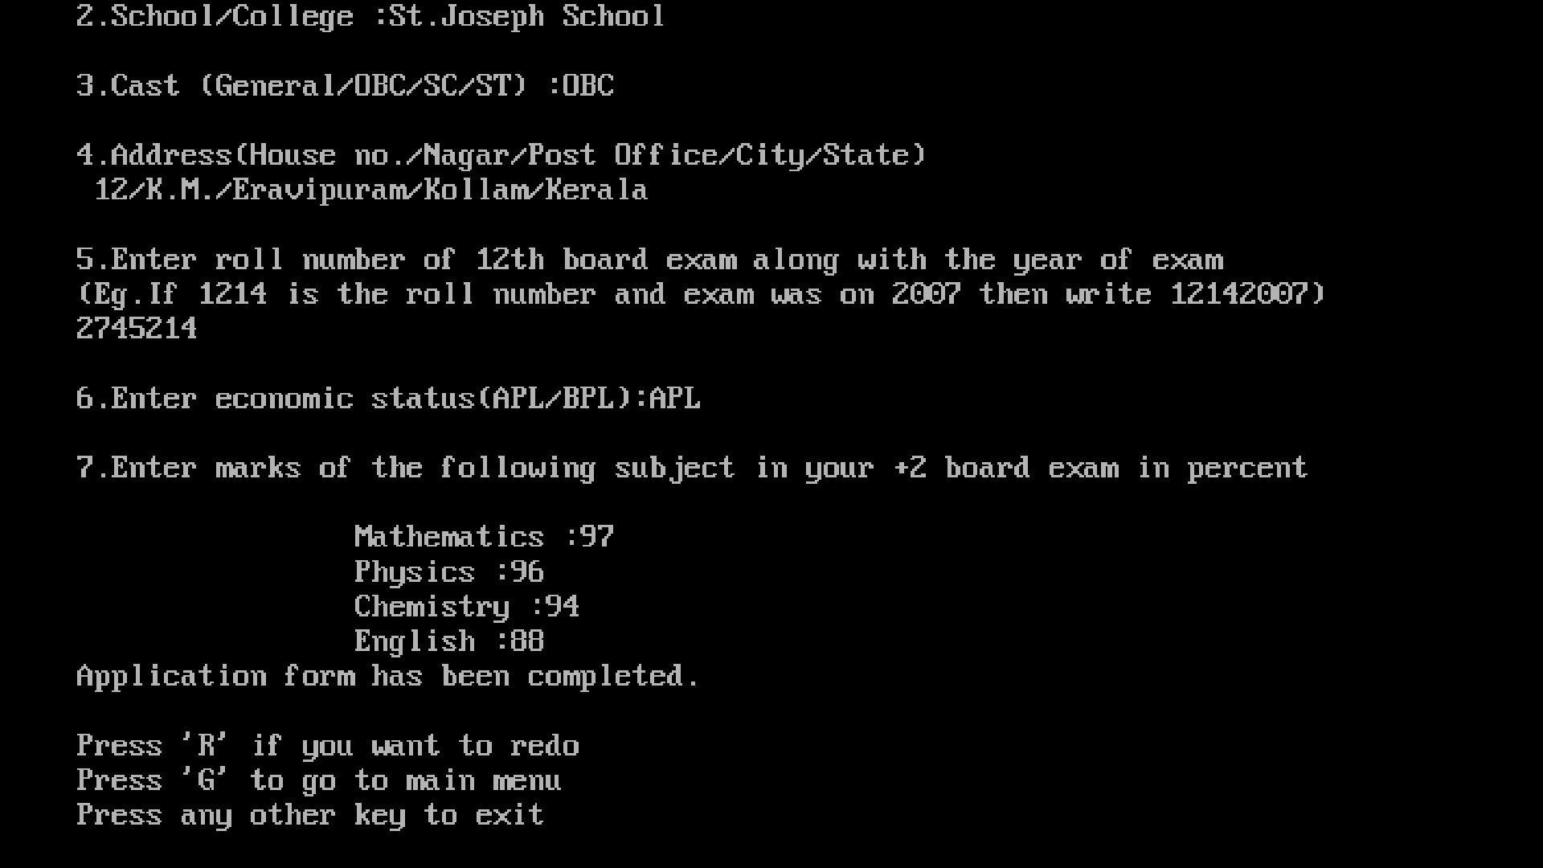

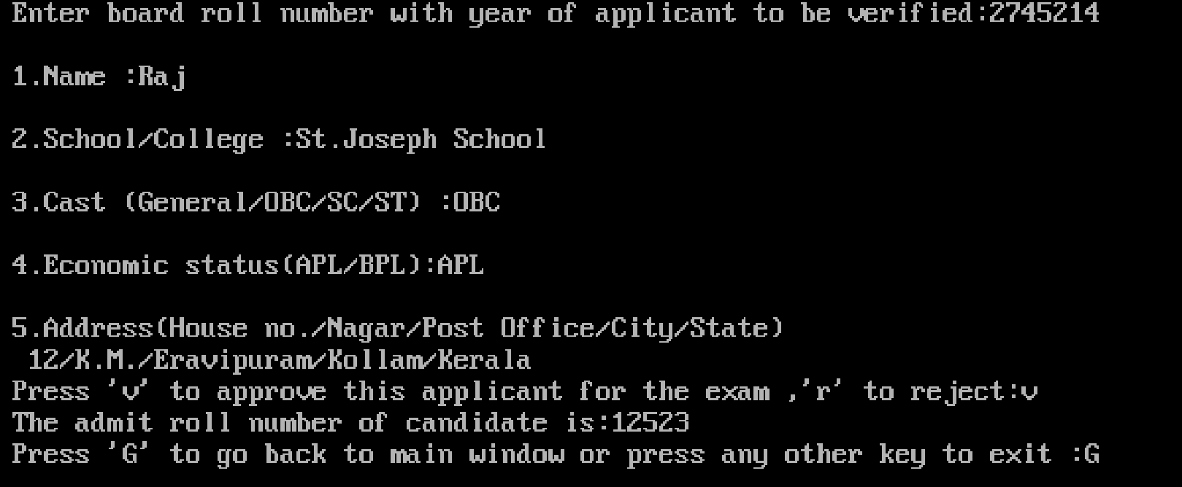

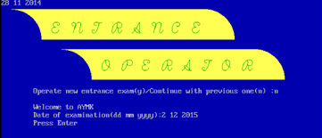

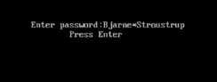

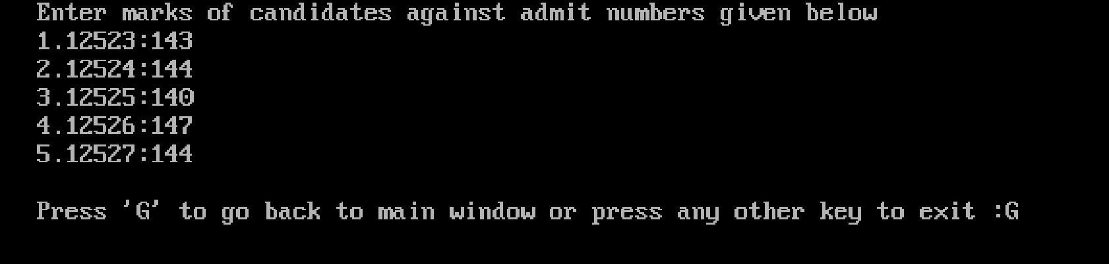

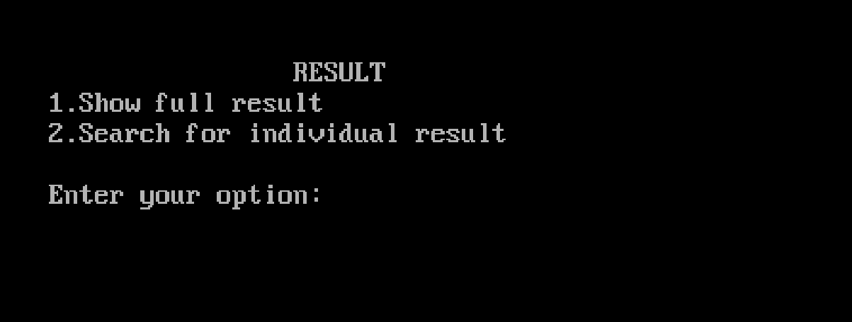

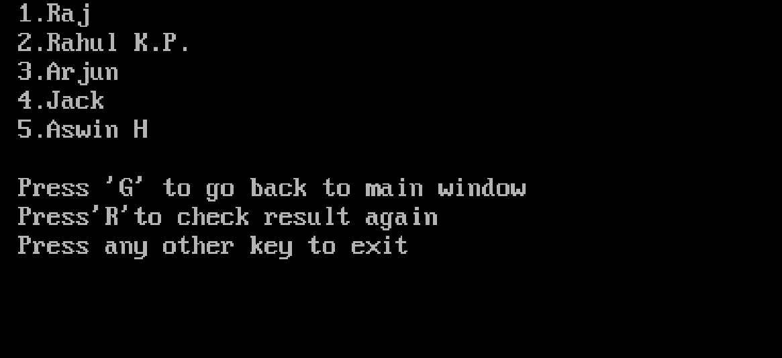

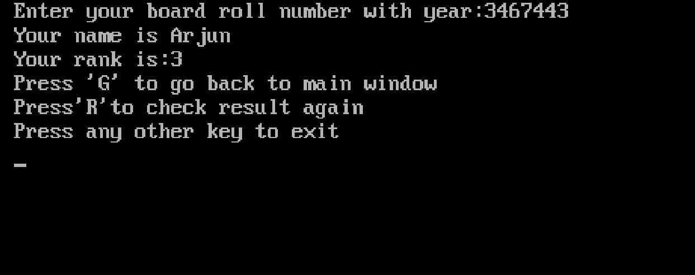

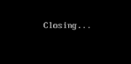

7. Conclusion & Future

Enhancements

The program has been effective in simplifying and fastening the various processes in an entrance exam. Features of C++ such as classes, objects, binary files, etc have been successfully implemented in the program which makes it less complex and more understandable. At the end of this coursework, I was able to:

* Explain object oriented programming concept and apply them to the modeling of real world system.
* Explain the object oriented paradigm and utilization of the offered facilities.
* Demonstrate the ability to develop and derive new class structures and organize them such that they will model real world systems within computers.

8.Reference

http://projects.icbse.com/cpp

http://cpp-project.blogspot.in/

http://www.cplusplus.com/